# **Emory Adams Park Survey**

# **Results Summary**

## **Total Survey Results:** 1,642

## **Opened:** Wednesday, August 7, 2024

## **Closed:** Tuesday, September 3, 2024

## **Q1:**

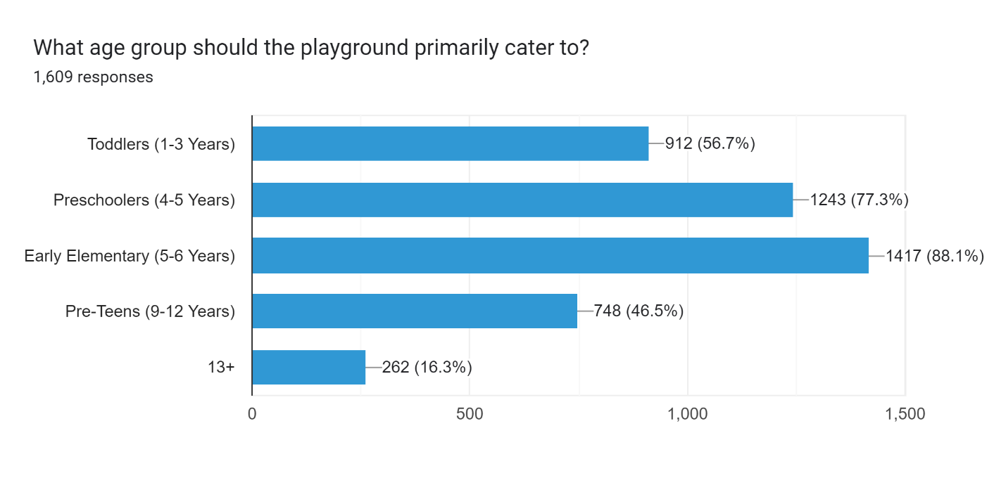

## **Q2:**

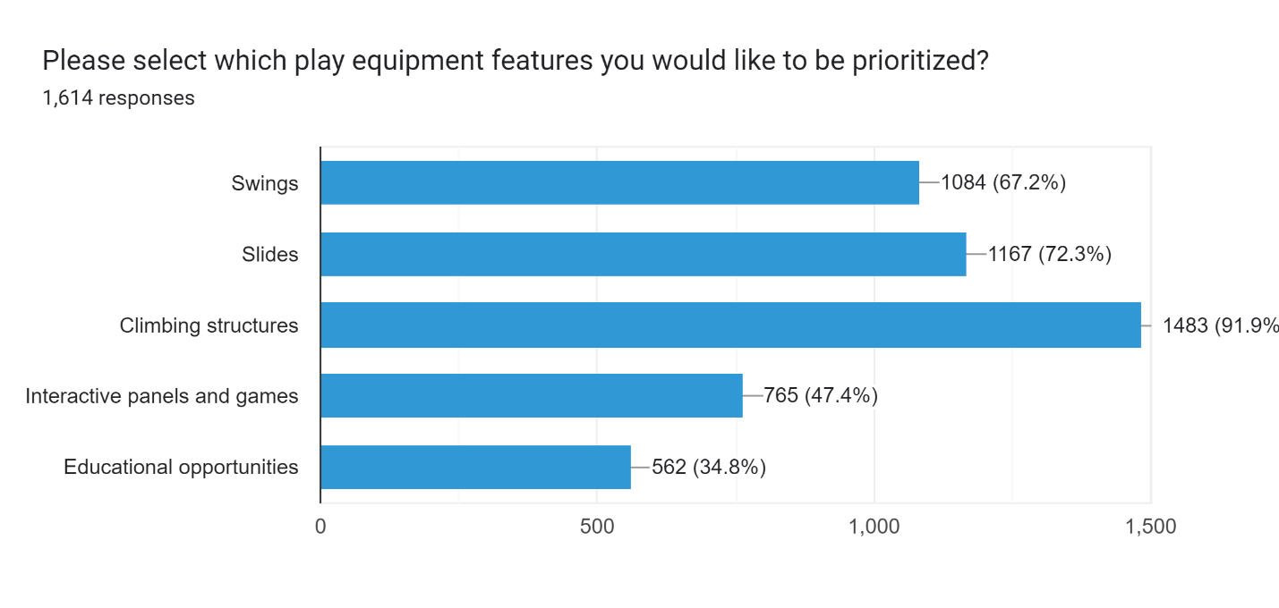

## **Q3:**

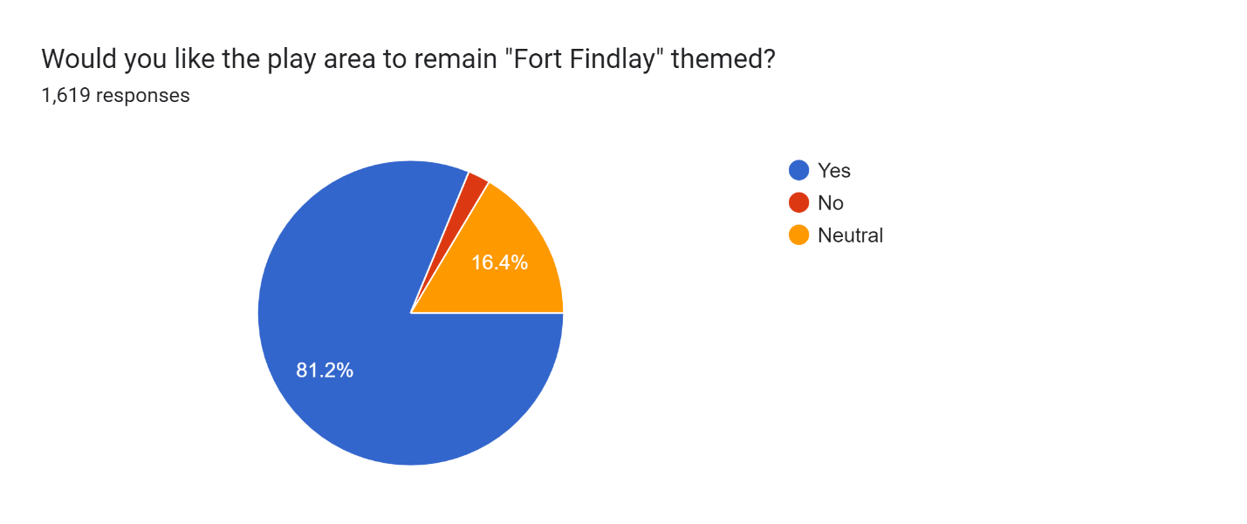

## **Q4: Do you have any special needs or accessibility requirements that should be considered? If yes, please specify. (435 Responses)**

**Key Themes and Ideas:**

* **Wheelchair Accessibility:** There is a strong emphasis on making the park fully wheelchair accessible. This includes ramps, accessible swings (e.g., wheelchair swings), and pathways that accommodate wheelchairs and walkers.
* **Special Needs Equipment:** Many respondents highlighted the need for specialized equipment such as swings for children with disabilities, sensory-friendly features, and adaptable play structures.
* **Sensory Needs:** Creating spaces and equipment for children with sensory processing disorders or autism, such as quiet areas, sensory boards, and textures that are comfortable for all kids, is frequently mentioned.
* **Restrooms and Changing Facilities:** Requests include adding adult changing tables, accessible restrooms, and family-friendly facilities.
* **Shade and Seating:** Requests for more shaded areas and additional benches for parents and guardians are common. This includes shaded structures and seating for grandparents or those with mobility issues.
* **Safety:** Many comments stress the importance of maintaining a fenced-in area with a single entrance for better supervision and safety. There are also calls for improved security measures such as cameras.

## **Q5: C:\Users\jhohman\AppData\Local\Microsoft\Windows\INetCache\Content.MSO\62CD38C9.tmp**

## **Q6:**

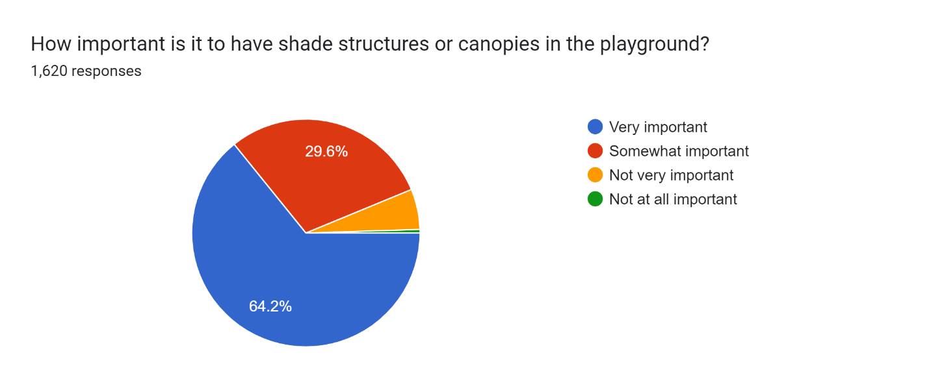

## **Q7:**

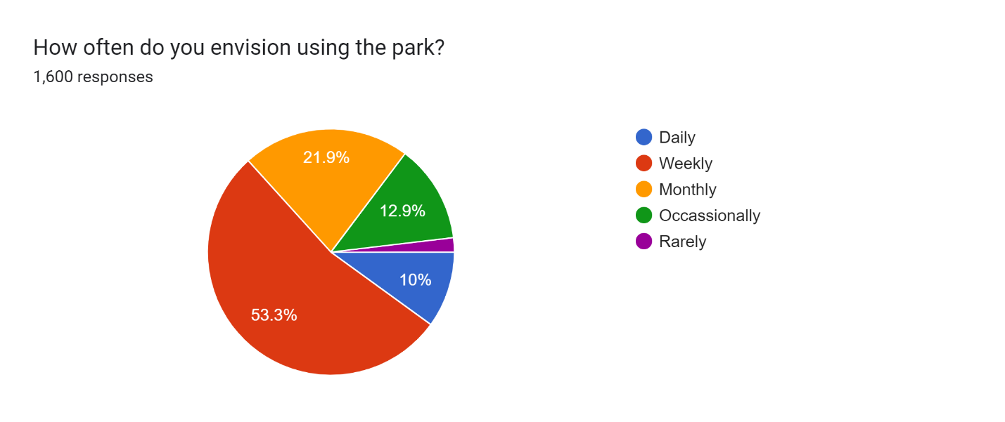

## **Q8: Are there any amenities that you do NOT want to see? (474 Responses)**

**Key Concerns:**

1. **Preserve the Fort Theme:**
   * **Sentiment:** The fort/castle theme is crucial to the park’s identity and is highly cherished by the community.
   * **Action:** Maintain and upgrade the existing fort structure. Any redesign should keep the fort’s distinctive look and character.
2. **Safety Concerns:**
   * **Sentiment:** There are concerns about unsafe features, such as high drop-offs, gaps, and lack of railings.
   * **Action:** Ensure all equipment and structures meet safety standards. Add railings, barriers, and safer materials to prevent injuries.
3. **Inclusivity and Accessibility:**
   * **Sentiment:** The park should cater to all children, including those with special needs.
   * **Action:** Include ADA-compliant equipment and features to make the park accessible for everyone.
4. **Maintenance and Upkeep:**
   * **Sentiment:** There is worry about the maintenance of landscaping and new features.
   * **Action:** Implement a sustainable maintenance plan to keep both new and existing areas in good condition.
5. **Separation of Age Groups:**
   * **Sentiment:** Concerns about older kids and teens causing issues in areas meant for younger children.
   * **Action:** Designate specific areas for different age groups, with clear separation between play zones and older kid amenities.
6. **Basketball Courts:**
   * **Sentiment:** Basketball courts should be separated from play areas for younger children to avoid conflicts.
   * **Action:** Position basketball courts away from primary play structures to ensure safety for younger kids.
7. **Play Structures vs. Green Space:**
   * **Sentiment:** Preference for more interactive play structures rather than extensive open green areas.
   * **Action:** Balance the design to include engaging play equipment while limiting large, unused grassy spaces.
8. **Community Sentiment and Historical Value:**
   * **Sentiment:** Strong attachment to the current park setup, with many community members opposing significant changes.
   * **Action:** Engage with the community to reflect their input in the redesign, preserving key elements like hand paintings and fundraising bricks.
9. **Concerns about New Designs:**
   * **Sentiment:** New design concepts may appear generic and not suited to the community's needs.
   * **Action:** Incorporate feedback to ensure the new design retains the park’s unique aspects and addresses all concerns.
10. **Visibility and Security:**
    * **Sentiment:** Issues with visibility and potential for unsavory behavior in hidden or enclosed areas.
    * **Action:** Improve visibility and lighting to deter inappropriate behavior and ensure parental supervision.

## **Q9: Are there any parks you have visited that you really liked? What features did they have that should be considered? (941 Responses)**

**Key Themes and Ideas:**

* **Splash Pad:** The desire for a splash pad was mentioned by the vast majority of respondents.
* **Preserve the Castle Theme:** The current castle-like structure is cherished for its unique, imaginative play opportunities. The preference is to refurbish and update it rather than replace it entirely.
* **Incorporate Modern Features:** Popular additions include a splash pad, climbing walls, zip lines, and interactive elements like musical instruments. There’s also interest in a paved path with donated riding toys for younger children.
* **Enhance Safety and Accessibility:** Improvements are needed for safety, including better fencing, a single entrance, and enhanced visibility. Accessibility features for all abilities, including wheelchair users, are important.
* **Additional Play Structures and Activities:** Suggestions include diverse climbing structures, balance beams, nature-inspired play areas, and seasonal features like a winter skating pond. Interactive play features and imaginative elements are also desired.
* **Community and Sentimental Value:** The park’s historical and sentimental value is significant. There’s a strong desire to retain its charm while modernizing. Community involvement in the redesign process is encouraged.
* **Maintenance and Upkeep:** Emphasis on regular maintenance and durable, low-maintenance materials is important to ensure the park remains in good condition.

**Suggestions for Moving Forward:**

* **Engage the Community:** Continue seeking input from park users, especially children, and consider forming a community advisory group to provide ongoing feedback.
* **Incorporate Feedback into Design:** Blend the beloved castle theme with modern features, ensuring safety and accessibility. Use durable materials and plan for future updates.
* **Plan for Future Growth:** Design the park to accommodate future changes and cater to various age groups. Include features for both active and imaginative play.
* **Promote Community Involvement:** Encourage local businesses and community groups to contribute through donations or volunteer work, and utilize local expertise for park development.

**Specific Parks Mentioned:**

* Miracle Park (Mentioned Often)
* Toledo Metroparks (Nature scape Play Areas) (Mentioned Often)
* Nathan Henderson Park in Sarasota, FL
* Celina’s Park (Splash Pad and Zip Line)
* Mini Bicycle Park in Seattle, WA
* Marimor Playground in Lima, OH (Mentioned Often)
* Memorial Park on TR 236
* Pandora Park
* Glandorf Park
* Chicago Bean (Use Local Artists)
* Ottawa Park in Toledo, OH
* Coffman Park in Dublin, OH (Mentioned Often)
* Bowling Green Park (Mentioned Often)
* Veterans Park in Delaware, OH (Mentioned Often)
* Hilliard, OH
* Legacy Park in Hanover, OH
* Weston Park
* Carey Park
* Upper Park
* Opportunity Park in Tiffin, OH
* Lakeview Park in Port Clinton, OH
* Whicker Park in Bluffton, IN
* Van Wert, OH
* The City Museum in St. Louis, MO
* Celina, OH
* Seminole, FL
* Glacier Ridge Metro Park in Plain City, Iowa
* Fort Imagination in Perrysburg, OH
* Promenade Park in Fort Wayne, IN
* Savannah’s Playground in Myrtle Beach, SC
* Dinosaur Park in Delaware, OH
* Kreager Park in Fort Wayne, IN
* St. Joes, MI
* Kalida, OH
* Science Center Playground in Greensboro, NC
* Valplayso Park in Valparaiso, IN
* Kominsky Legacy Park in New Bremen, OH